NEAIR – Instructions for “Viz” using IPEDS data

First Year Full Time Freshmen Financial Aid

Deb Fyler, Cornell University (djf5@cornell.edu)

Live demo

Nov 2013

|  |
| --- |
| **Vocabulary**   * **Workbook**. A Tableau document with the suffix .twb. It may contain worksheets and dashboards.   + A **packaged workbook**, .twbx, is a Tableau workbook integrated with the data source and compressed. * **Worksheet**. Like in Excel, one ‘tab’ within a workbook. * **Dashboard**. Also a ‘tab’ within a workbook, a dashboard is a presentation space for one or more worksheets. It may be linked to multiple or many datasets. * **Data.** As with SPSS or another statistical software package, the data is generally a separate, independent file. In Tableau, we start by “connecting” to a data file, such as a .xls file or a .csv file. * **Data Extract**. *Sort of* similar with the .sav file with SPSS, you can save the data in a format that will improve the performance of Tableau. This is a data “extract”, .tde. Data is optimized for performance. * **Viz**. The hip Tableau way to say “graph” or “chart.” |

**Connect to a Data File**

1. 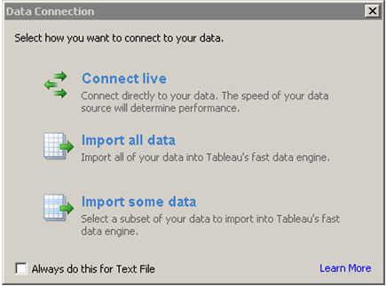Open Tableau and select “Connect to data”
2. Select text file and choose to “IPEDS FTF Fin Aid 08-12”. Comma delimited is the default.
3. This is a file I downloaded from IPEDS late last month. It contains information on financial aid for first time full time degree seeking freshmen for year 2008 to 2012 for colleges and universities of interest. All data is in aggregate.
4. Select “Import All Data”. Tableau will ask where you want to store the extract file that results (anywhere is fine, it’s your computer!).

**Make a Table**

Tableau imports your data and makes determinations on data type – that are not always correct. Lucky for you, in this dataset, they almost all are!

|  |
| --- |
| **Vocabulary**   * **Dimensions**. Roughly speaking, these tend to be categorical variables that you might want to use to break the data into groups (e.g. sex, race, major). You could also think of dimensions as your “independent variables.” Tableau starts by assuming that all your non-numeric data is data that might want to use for breakouts. You are not stuck with this designation. * **Measures**. Tableau starts by assuming that all *numeric data* is something that you might want to sum, average, or trend. You might think of measures as your “outcomes” or “dependent variables.” Of course it is not always appropriate to take an average of a variable stored numerically (like, say, race stored as numeric codes). Therefore, you may want to change some of your “measures” into “dimensions”… a very easy task: just drag them. |

1. Make unitid and Year dimensions.
2. Now make a crosstab: Drop the ‘number receiving institutional grant aid’ into center of cross-tab. Note that it sums this measure.

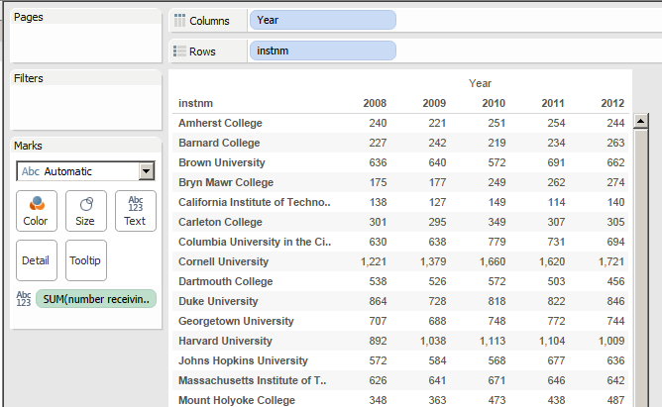

**Make Groups**

Make a group ‘College Group”: Ivy, Co Ed College, All else are Non Ivy Univ. Right click on Instnm and select “Create Group” – select the colleges you want to group, rename and then press OK.

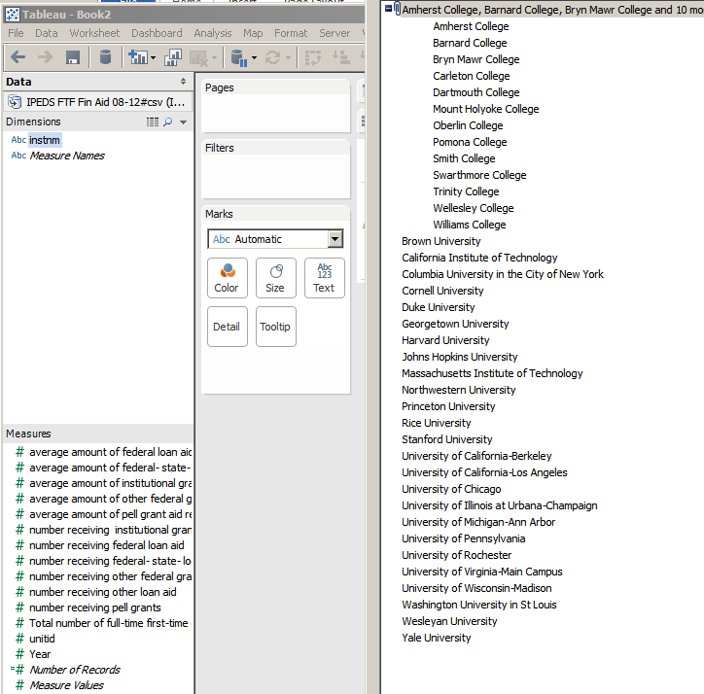

1. Filter on College Group to Ivy and Non Ivy Univ. Make it a “universal limit”:

Drag new field “instrm (group)” to the filter box and select Ivy and Non Ivy Univ. Press OK

Now – right click on the filter and select “Apply to worksheets” and then “All using this datasource” . Now all worksheets you create in Tableau document will only show Ivy and Non-Ivy Univ.

**Calculations**

Create some calculated fields by right clicking anywhere in measures or the dimension box and selecting “Create calculated field”. Make sure you change the name to something meaningful.

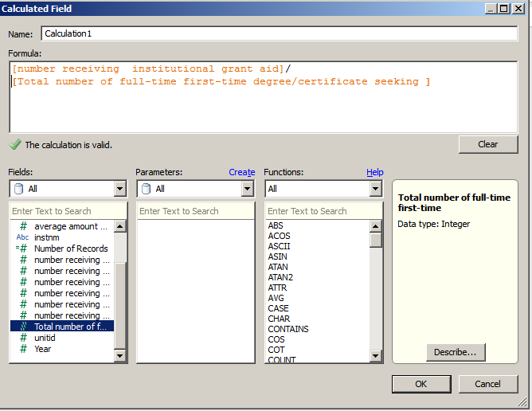

* “Percent Aid”: [number receiving federal- state- local or institutional grant ai]/[Number of full-time first-time degree/certificate seeking Freshmen ]
* “Percent Inst Aid”: [number receiving institutional grant aid]/[Number of full-time first-time degree/certificate seeking]
* “Percent Pell”: [number receiving pell grants]/[Total number of full-time first-time degree/certificate seeking ]

**Charts**

* Create a duplicate sheet (right clicking) or just click on the bottom to add a new sheet and make a chart.

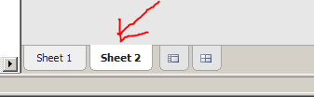

* Edit colors and make a line graph by dragging and dropping the fields to look like this:

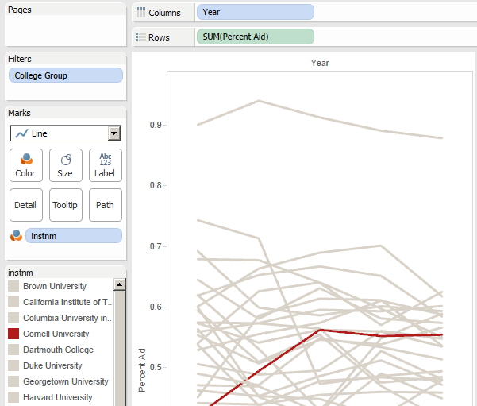

Make sure your Marks are set to “Line”. Edit colors by selecting the down triangle.

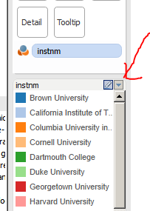

* Format axes to be percentages or better yet, format the fields to be percentages!

Right click on the field and select “Default Properties” then “Number Format” and select Percentage.

**Show Me**

1. Start a new sheet.

Limit to Year: 2008 and add in the calculated fields. It should look like this:

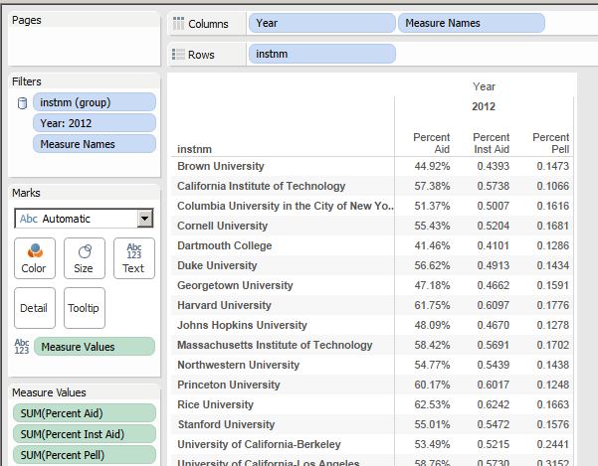

1. Select the horizontal bar graph in the “Show Me” wizard and insert “instnm” into the color box. Sort on the first column (click on little icon that appears at top of column).

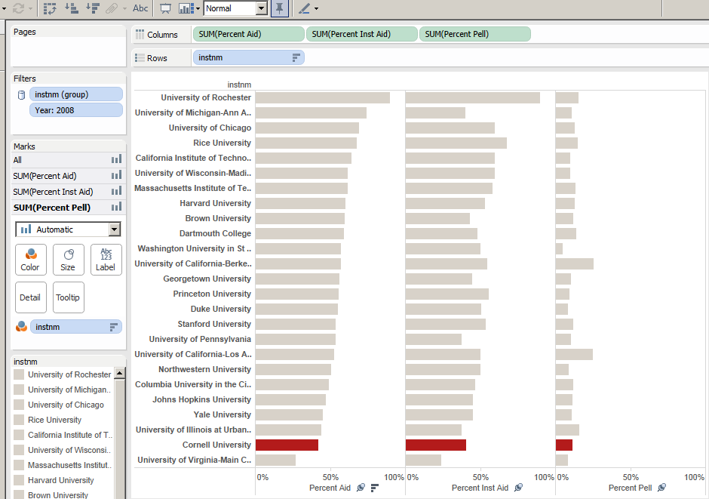

“Fix” the range by right clicking on the X axis under the column of interest.

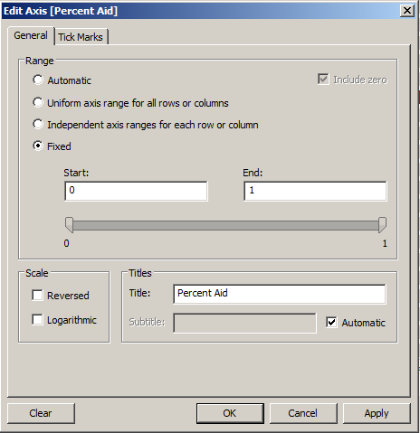

1. Add reference lines to Percent Aid, Percent Inst Aid and Percent Pell (right click on X axis – select “Add Reference Line”)

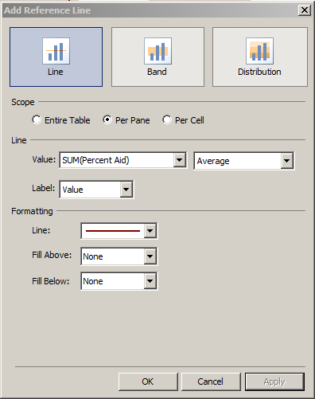

* Make “single value slider” quick limit for “Year”. Right click on Year (it should be a dimension) and select “Show Quick Filter”. Edit the filter by selecting the little down triangle in the top right and choosing “Single value slider”. Also select “Customize” and un-click the “Show “All” Value”.

Beginning: 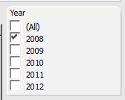 Now this: 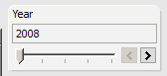

1. Make a dashboard, add a title. Size it for an iPad portrait, and modify each worksheet to fit entire view. Format.

Click on cross hatch tab to make a dashboard:

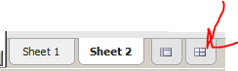

Drag the sheets you want to place onto the dashboard. Format as needed – lots of options here. Add a Text box to the top. Modify the dashboard to be a specific size. This box will appear if you click anywhere off the dashboard:

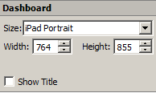

* Modify Tooltips as needed (top menu Worksheet – Tooltips)

|  |
| --- |
| **Vocabulary**   * **Tooltips**. When you mouse over data displayed in a Tableau dashboard, text will appear. This text is a “tooltip.” You can control what, exactly, is displayed when people mouse over using the Tooltip function on the Marks card. |

**Sharing**

* Publish to Tableau Public (free) to post on the web for all to see and for all to download – copy the email link to share.

(Server>Tableau Public>Save to Web As) Note that you will need to set up an account first.

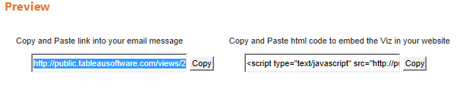

* Publish to Tableau Public Premium ($$) to post to the web (can disallow downloading data).
* Send whole doc via e-mail to someone who has Tableau Reader (free) on their laptop or computer.
* Publish to your Tableau server ($$)